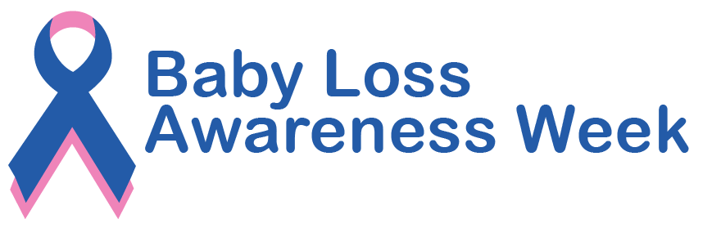

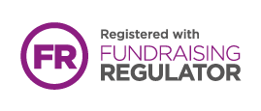

Sands. Charity Registered in Scotland SC042789, England and Wales 299679. We also operate in Northern Ireland. Company Limited by Guarantee Number: 2212082. Registered Address: 10–18 Union Street, London, SE1 1SZ.
sands.org.uk
Help Sands save babies’ lives and support anyone
affected by pregnancy loss or the death of a baby.

